|  |  |
| --- | --- |
| Name: | Prerna Sunil Jadhav |
| Sap Id: | 60004220127 |
| Class: | T. Y. B. Tech (Computer Engineering) |
| Course: | Advance Algorithm Laboratory |
| Course Code: | DJ19CEL602 |
| Experiment No.: | 01-C |

**AIM: Perform Amortized Analysis of Multipop / Dynamic Tables / Binary Counter using**

**Aggregate, Accounting and Potential method. (Amortized Analysis)**

1C) Amortized Analysis (Potential method)

**CODE:**

def potential(n):

    size = 1

    total = 0

    dcost = 0

    icost = 0

    bank = 0

    phi = 0

    ci = 0

    phi_prev = 0

    print("Elements\tDoubling Copying Cost\tInsertion Cost\tTotal Cost\t\tBank\t\tSize\t\tPhi\t\tCi")

    for i in range(1, n + 1):

        icost = 1

        if i > size:

            size *= 2

            dcost = i - 1

        total = icost + dcost

        phi = 2 * i - size

        ci = total + phi - phi_prev

        bank += (3 - total)

        print(i, "\t\t\t\t", dcost, "\t\t", icost, "\t", total, "\t\t\t", bank, "\t\t", size, "\t\t", phi, "\t\t", ci)

        icost = 0

        dcost = 0

        phi_prev = phi

potential(10)

**OUTPUT:**

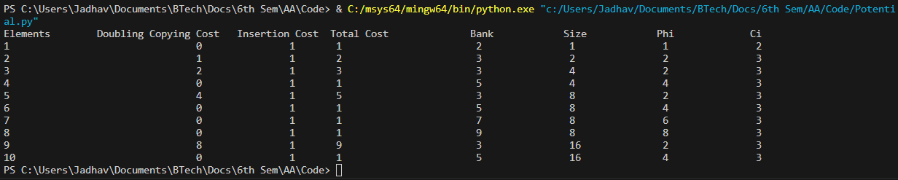

**CONCLUSION:**  Hence we studied amortized analysis-Potential method.